Antonia Pocock

56 Cheever Place, 3rd floor  
Brooklyn, NY 11231

[antoniapocock@gmail.com](mailto:antoniapocock@gmail.com)

**FEDERAL ART PROJECT** Word Count: 1093

The Federal Art Project (FAP) was a branch of the Works Progress Administration (WPA), a work relief agency established in 1935 by President Franklin Delano Roosevelt’s Second New Deal. Aimed at mitigating unemployment during the Great Depression, the WPA hired 8.5 million Americans for public works projects, focused mainly on infrastructure improvements. The WPA’s Federal Project Number One—which comprised the FAP, the Federal Writers’ Project, Federal Theatre Project, Federal Music Project, and Historical Records Survey—subsidised the creative activities of 40,000 artists, writers, actors, and musicians. The FAP commissioned 5000 visual artists to paint murals in public buildings; create easel paintings, sculptures, prints, and drawings that were displayed in travelling exhibitions; teach in newly established Community Art Centers; document the activities of the WPA photographically; and design posters promoting New Deal policies. In addition to providing financial aid to destitute artists, the FAP aimed to preserve their skills and encourage a thriving American artistic tradition at a time when there were few private commissions. Though it operated nationwide, the FAP was concentrated in New York City, where 3000 artists participated in the project, including many who went on to achieve international recognition after World War Two as part of the Abstract Expressionist movement. By 1941, the FAP was limited to the production of war propaganda and training aids, and in 1943, President Roosevelt terminated all WPA projects.

The FAP was preceded by two government sponsored art programs housed within the Treasury Department: the Public Works of Art Project (PWAP, 1933–1934) and the Section of Painting and Sculpture (1934–1943). The impetus for these programs was a letter that President Roosevelt received from the painter George Biddle [hyperlink to: <http://www.aaa.si.edu/collections/viewer/george-biddle-diary-transcript-14231>], with whom he had attended the Groton School and Harvard. Inspired by the Mexican mural movement of the 1920s, Biddle suggested that the United States government hire young artists to decorate public buildings with murals expressing the social ideals of the new administration*.* Roosevelt, who oversaw a state relief program for artists when he was governor of New York, was receptive to the idea. He encouraged Biddle to meet with officials in the Treasury Department, which controlled funds for the embellishment of public buildings. Treasury advisor Edward Bruce was enthusiastic about Biddle’s plan, which he implemented through PWAP and the Section, programs that commissioned art in newly erected public buildings. Though partially supported with relief funds from the Civil Works Administration (precursor of the WPA), the Treasury Department art programs did not select artists on the basis of need, but rather on the basis of Bruce’s aesthetic values.

In contrast to the quality standards upheld by the Treasury Department art programs, the WPA’s FAP employed artists on the basis of need alone. WPA director Harry Hopkins enlisted Holger Cahill, specialist in American Folk Art and acting director of the Museum of Modern Art (MoMA) in New York, to head the FAP. Unlike Bruce, who required that artists portray the “American Scene,” Cahill allowed artists the freedom to explore any theme or style they wished. With a focus on mass-participation, the FAP supported more artists than did the Treasury art programs. In addition to its mural division, the FAP included divisions for easel painting, sculpture, graphic arts, and photography.The FAP also promoted art education in public schools through its Art Teaching Division, sent New York artists to other cities as part of its Loan Artists Program, supported traveling exhibitions via its Exhibitions Division, and offered free lectures and workshops at its Community Art Centers.

Notable artists enrolled in the project include those established within the early twentieth century American avant-garde, such as Stuart Davis, Marsden Hartley, Stanton Macdonald-Wright,and Jacob Lawrence, as well as a younger generation who went on to form the New York School, including Arshile Gorky, Willem de Kooning, Mark Rothko, Philip Guston, Jackson Pollock, Lee Krasner, and David Smith. FAP artists producedover 2500 murals in public buildings; 17,000 sculptures; 108,000 easel paintings; 11,000 graphic works; and a 22,000 piece Index of American Design, which recorded traditional American design, craft, and decorative objects. They also staffed over 100 Community Art Centers nationwide, including the still extant Walker Art Center. Government sponsorship of the arts on such a large scale was unprecedented in the United States.

Mural art was at the core of FAP philosophy and constituted its most iconic works. Cahill wrote in the catalogue of an exhibition of WPA art held at MoMA in 1936: “Mural painting…by its very nature it is social.…this work, as it develops, gives promise of a truly monumental art which will express with honesty, clarity, and power the experience and ideas of American communities” (Cahill 1936). The majority of FAP murals were influenced by larger artistic movements in the 1930s, primarily Regionalism and Social Realism, both of which portrayed everyday scenes of American life, especially industrial and agricultural labor. Edward Laning’s Ellis Island mural, depicting the construction of the Central and Union Pacific Railroads, drew particular attention for the accuracy of its historic details, down to the height of boots on army officers, and the round rather than square shape of rail ties appropriate to nineteenth century technology. Such a documentary impulse reflected a widespread craze for historical heroes and events. This same urge to gather factual information guided the Index of American Design, as well as the Library of Congress, which recorded oral histories of sharecroppers and regional folk songs.

Unlike the Section, the FAP supported experiments in abstraction. Among the first abstract mural cycles created under the aegis of the WPA was Gorky’s *Aviation: Evolution of Forms under Aerodynamic Limitations,* executed between 1935 and 1937 for the newly constructed Newark Airport Administration Building. Gorky’s murals explored the theme of aviation in a Cubist vocabulary inspired French artists Pablo Picasso and Georges Braque.Gorky’s bold, modernist style echoed the Art Deco building in which they were installed. Like most WPA murals, Gorky’s Newark Airport murals were not painted directly on the wall, but on large-scale canvases*.* Only two of the original ten panels survive, *Aerial Map* and *Mechanics of Flying*, both rediscovered in 1973 beneath layers of paint.

**References and further reading**

[http://livingnewdeal.berkeley.edu/](http://livingnewdeal.berkeley.edu/about/)

Cahill, H. (1936) *New Horizons In American Art* (New York: Museum of Modern Art), 32–33

O’Connor, F. ed*.* (1972) *New Deal Art Projects: An Anthology of Memoirs.* Washington, D.C.: Smithsonian Institution.

Harris, J. (1995) *Federal Art and National Culture: the Politics of Identity in New Deal America.* Cambridge: Cambridge University Press.

Grieve, V. (2009) *The Federal Art Project and the Creation of Middlebrow Culture.* Urbana, IL: University of Illinois Press, 2009.

**Images**

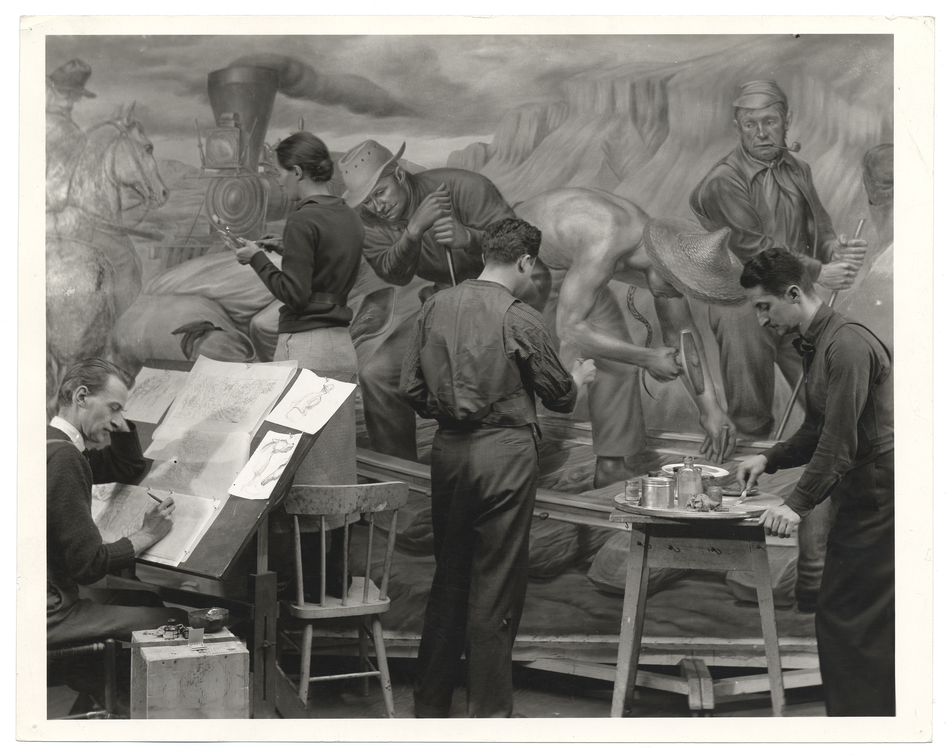

Edward Laning (1906–1981) and assistants working on a mural, no longer extant, titled *The Role of the Immigrant in the Industrial Development of America,* commissioned by the WPA Federal Art Project for the dining room of the Ellis Island Administration Building, ca. 1937. Unidentified photographer. Archives of American Art, Smithsonian Institution, Washington, D.C.

**[Public domain:** [**http://commons.wikimedia.org/wiki/File:Archives_of_American_Art_-_Edward_Laning_-_2937.jpg**](http://commons.wikimedia.org/wiki/File:Archives_of_American_Art_-_Edward_Laning_-_2937.jpg)**]**

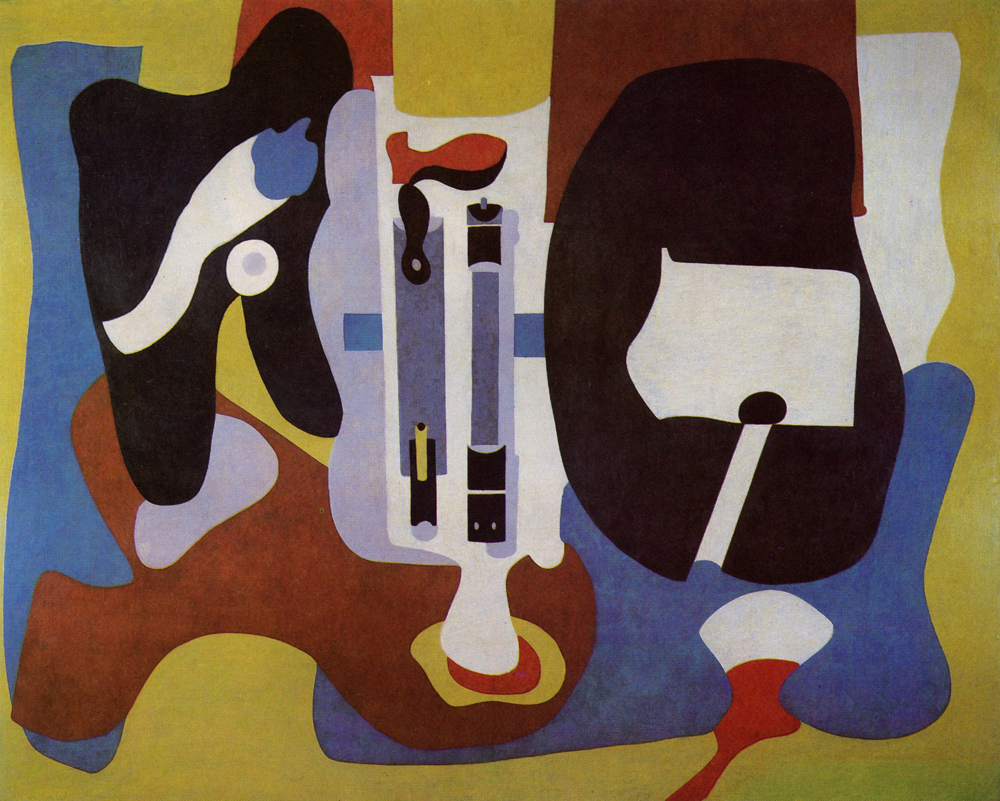

Arshile Gorky (1904–1948), Mechanics of Flying, 1936–1937, oil on canvas, 108 x 133 inches. One of two extant panels from the mural cycle Aviation: Evolution of Forms under Aerodynamic Limitations, commissioned by the WPA Federal Art Project and originally installed at the Newark Airport Administration Building, New Jersey. Newark Museum, New Jersey, on loan from the Port Authority of New Jersey and New York.

**[Rights held by Artists Rights Society (ARS). For information on how to obtain permission for reproduction, visit** [**http://www.arsny.com/procedures.html**](http://www.arsny.com/procedures.html)**]**